**GOTHIC**

**GOTHIC SCULPTURES**

The period is generally divided into **Early Gothic (1150-1250), High Gothic (1250-1375),** and **international Gothic (1375-1450).** Primarily a form of Christian art, it flourished initially in Cathedrals and churches across the *Ile de France* and surrounding region in the period 1150-1250, and then spread throughout northern Europe. The chief hallmark of Gothic art was its unique integration of the arts of **sculpture, stained glass and architecture** - notably, in the great **cathedrals of Chartres, Amiens, Reims and Notre Dame de Paris.** The planar forms of the previous Romanesque style were replaced by a new focus on line, and its soaring arches and buttresses permitted the opening up of walls for unprecedently huge windows filled with beautifully translucent holy images, far surpassing anything that murals or mosaic art  had to offer. During the late 14th and early 15th centuries, Gothic fused with Italian art to produce a more secular style, called International Gothic, as it spread across Burgundy, Bohemia and northern Italy.)

**Early Gothic Sculpture**

As in the Romanesque period, the best Gothic sculptors were employed on architectural decoration. The most important examples of figurative sculpture to survive are on portals, as in the **church of Saint-Denis** whose western portals (constructed 1137-40), combined features that remained common throughout the Gothic period: **a carved tympanum**; **carved figures arranged in the *voussoirs***, or **wedge-shaped pieces, of the arch**; and more figurative carvings attached to the sides of the portal. As it survives, Saint-Denis is rather disappointing; the side figures have been lost and the remainder heavily restored.

**Trend Towards Greater Realism**

The general effect is now better appreciated on the west front of Chartres cathedral, whose portals illustrate the development of the Gothic style. If one compares the portals at Chartres (c. 1140-50) with those of 13th-century Reims, one can see that the development of sculpture during this early period of Gothic art is toward increased realism, and away from the rather wooden feel of early sculptures. As it was, this was achieved not by continuous evolution, but in a series of stylistic impulses. The first of these impulses can be seen in the sculpture on the west front of Chartres. The figures, with their stylized gestures and minutely pleated garments, are barely "real", and their forms are closely aligned with the architectural composition.

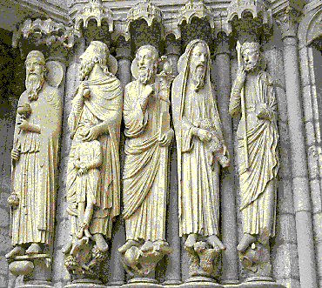

Similar examples can be seen at Angers, Le Mans, Bourges, and Senlis cathedrals. The second creative impulse derived (1181-1210) from the region of the Meuse, in the work of the goldsmith Nicholas of Verdun, marked by graceful, curving figures and soft Greek-like ridged-and-troughed drapery (Muldenstil). A restrained version of this style decorated the main portals of the transepts of Chartres (c.1200-10), and can also be seen in Reims cathedral. A third impulse towards realism in Gothic sculpture, based on 10th century Byzantine prototypes, seems to have originated at Notre-Dame, Paris (c.1200). Instead of swirling drapery and curved figures, this style is characterized by figures with a square, upright appearance, who are quite restrained in their gestures. A good example of this style is the west front of Amiens cathedral (c.1220-30).

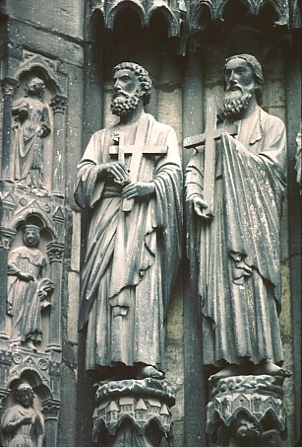

A fourth style of realism originated at Reims with a craftsman named after his most famous figure, the Joseph Master. Ignoring both the gestural restraint of Amiens and the drapery of the*Muldenstil*, he produced (c.1240) figures with characteristics that endured for the next 150 years: namely, dainty poses and faces and thick drapery hanging in long V-shaped folds that envelop the figure. Gothic cathedral sculpture had a wide-ranging influence on Late Gothic painters and illuminators

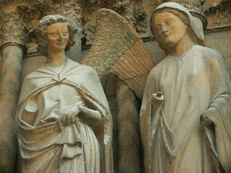

**High Gothic Sculpture**

In general, this period saw a decline in architectural sculpture. Due to the focus placed on geometric patterning by the *Rayonnant* style, this is not surprising. A few portals, like those on the west front of Bourges cathedral, were completed, but they have a limited interest.

In contrast, the type of sculpture that was expanding with great rapidity was the more private one, exemplified by tombs and other funerary monuments. They included the tomb chest, typically decorated with small figures in niches - figures known as weepers, since they usually represented members of the family who were in mourning. Later, in the early 14th century, appeared representations of heavily cloaked professional mourners.

This sculptural trend was initiated by Louis IX in his monuments to his ancestors and next of kin, mostly located in Saint-Denis (1260-70), though severely damaged during the French Revolution. Earlier precedents may be found, Louis IX's efforts did much to popularize the idea of the dynastic mausoleum, and numerous other important people followed suit.

In England, as in France, most of the virtuosity in carving was ploughed into private tombs and monuments. The best surviving Gothic mausoleum is Westminster Abbey, where monuments carved in a variety of mediums (notably purbeck, bronze, alabaster, and freestone) are further enhanced by the floors and tombs executed by Italian mosaic workers employed by Henry III. The tomb of Edward II (c. 1330-35), in Exeter Cathedral, notable for its elaborate medieval canopy, is another fine example of English Gothic.

German High Gothic sculpture is exemplified by the elegant draped figures around the choir of Cologne cathedral (consecrated in 1322), and by the impressive figures on the west front of Strasbourg cathedral (carved after 1277), which appear to be strongly influenced by the Joseph Master of Reims. As usual German sculpture tends to be far more expressive than similar French work.

In Italy, the most important 13th-century sculptors included [Nicola Pisano](http://www.visual-arts-cork.com/sculpture/nicola-pisano.htm)(1206-78) and his son [Giovanni Pisano](http://www.visual-arts-cork.com/sculpture/giovanni-pisano.htm) (1250-1314). Both worked mostly in Tuscany, and both executed pulpits that rank as their major completed works: Nicola being noted for sculpture in the Pisa Baptistery (1259-60) and Siena cathedral (1265-68), while Giovanni's pulpit in S. Andrea Pistoia (commpleted 1301), while technically less refined, is emotionally much more dramatic.

In Milan, a shrine for the body of St. Peter Martyr was carved by [Giovanni di Balduccio](http://www.visual-arts-cork.com/sculpture/giovanni-balduccio.htm) (c.1290-1349) in a style derived from the Pisano studio. More famous followers of Pisano include [Arnolfo di Cambio](http://www.visual-arts-cork.com/sculpture/arnolfo-cambio.htm) (1240–1300/10), and Tino di Camaino, who worked at the Neapolitan court (c.1323-37). Arnolfo di Cambio's sculpture is solid and impassive. He excelled at formal compositions, such as the funerary chapel and the tomb of Pope Boniface VIII. Also he was the first architect of Florence cathedral (founded 1296). Tino di Camaino achieved fame as a tomb sculptor, and the largest collection of his work is in Naples.

Another noted Italian Gothic sculptor was [Andrea Pisano](http://www.visual-arts-cork.com/sculpture/andrea-pisano.htm) (1295-1348) (aka Andrea da Pontedera). His most famous sculptures were executed in Florence, the most important of which were his three bronze doors for the baptistery of the Cathedral of Florence (completed in 1336). He was highly influenced by the sculpture of Giovanni Pisano, as well as the painting of the Proto-Renaissance artist Giotto, which caused Andrea to make his figures rather stocky and solid.

**Sculpture**

**Pisano:**



**Description: Gilded bronze, height of portion shown cm 55, detail from panels on South Door. 1330-1336**



**Description: Gilded bronze, height of portion shown cm 50, detail from panels on South Door. representing virtue. 1330-1336.**



**Description: Marble, detail, 1347/48. Unique testimony of his work in Orvieto. Almost certain intervention by his son, Nino.**



**Description: Marble, detail from about 1419. Angle relief facing the sea, perhaps by the Lombard Sculptor Matteo Roverti**



**Description: Stone, height of portion shown cm 40. Detail from pilaster relief on façade before 1330, Anonimo**



**Marble, detail, 1361. Completed while master builder at Florence Cathedral working on the second level of bas-relief..Alberto**

**GOTHIC PAINTINGS**

Gothic painting followed the same stylistic evolution as did sculpture; from stiff, simple, hieratic forms toward more relaxed and natural ones. Its scale grew large only in the early 14th century, when it began to be used in decorating the retable (ornamental panel behind an altar). Such paintings usually featured scenes and figures from the New Testament, particularly of the Passion of Christ and the Virgin Mary. These paintings display an emphasis on flowing, curving lines, minute detail, and refined decoration, and gold was often applied to the panel as background colour. Compositions became more complex as time went on, and painters began to seek means of depicting spatial depth in their pictures, a search that eventually led to the mastery of perspective in the early years of the Italian Renaissance.

In late Gothic painting of the 14th and 15th centuries secular subjects such as hunting scenes, chivalric themes, and depictions of historical events also appeared. Both religious and secular subjects were depicted in manuscript illuminations--i.e., the pictorial embellishment of handwritten books. This was a major form of artistic production during the Gothic period and reached its peak in France during the 14th century. The calendar illustrations in the Très Riches Heures du duc de Berry (c. 1416) by the Limburg brothers, who worked at the court of Jean de France, duc de Berry, are perhaps the most eloquent statements of the International Gothic style as well as the best known of all manuscript illuminations

Europe was still not ready for paintings as a major public art form. Tapestry was still popular (and warmer) as a decorative wall covering, while most Gothic cathedrals, with their lack of wall-space, had less interest in wall paintings. Instead for color effects Gothic architects relied on stained-glass windows, which had now become very much larger than in the Romanesque period.

Manuscript illumination was superseded by printed illustrations in the second half of the 15th century. Panel and wall painting evolved gradually into the Renaissance style in Italy during the 14th and early 15th centuries but retained many more of its Gothic characteristics until the late 15th and early 16th centuries in Germany, Flanders, and elsewhere in Northern Europe**.**



Gothic art, most notably paintings, attempted to use perspective. This means that factors such as distance and the angle of subjects are considered. For the most part, paintings would usually be in the form of frescoes or murals. They also appeared to be more realistic, seeing that painters based their subjects on observation. Gothic art provides an additional challenge as it refers both to a time and a place.



Giotto mastered the use of shading and created realistic figures

Themes

Gothic art displayed scenes from the Bible. In the case of stained glass images, those of saints would usually show the actions, deeds, or events which they are typically remembered for. Statues also featured the same.



Later on, artists began to depict studies of real life, specifically in their paintings. They also went on to use animals and mythical creatures as subjects. In the case of statues, a good example would be gargoyles on top of buildings.

**Prominence and Spread**

Since most art had been for religious purposes and the influence of the Church throughout Europe, Gothic art spread like wildfire. Louis IX of France was an avid supporter of this new movement as he was very much into art.



King Louie IX, who was very interested in art

Artists and architects from all over Europe, impressed by this new style, began to mimic it in their respective homelands.

***Early Attempts At Perspective***



We can see the development of Italian Gothic perspective in two main forms: interior perspective, providing depth to an enclosed space, and exterior perspective, with a well-established foreground, midground and background.

We can see the first steps toward interior perspective in a detail from Duccio's Maesta Altar. Unlike previous artwork, in which the figures stand in front of a flat backdrop, these figures exist inside an enclosed space. Sort of like a niche in the painting, like the architectural housing of gothic sculpture.

We can see the development of this trend in *The Birth of The Virgin* by Pietro Lorenzetti. In this painting, we see an even greater command of depth, and each figure seems to fully occupy this three-dimensional space. We also see additional architectural elements finding their way into painting, like the beautifully executed rendition of a rib vault ceiling above our figures. The development of interior perspective is impressive, but not nearly so much as the gradual improvement of exterior perspective.

**Gothic Book Painting**  
Gothic book illustrations includes Books of Hours, Missals, Apocalypses, Psalters, and Bibles. In these masterpieces the Gothic artist, no longer a mere contributor to the architectural ensemble, can unleash his fancy and indulge all his whims. The figures are sometimes elongated to the verge of caricature, like fashion drawings of today. Grotesque creatures, as well as humorous or macabre touches abound. As the type develops it becomes more restless. The eye is not given a moment's peace. Intricate decorative backgrounds, borders of ivy leaves made even more spiky than nature had designed them, later on, landscape backgrounds with clumps of elaborate flowers in the foreground, scenes from contemporary life, sports and pastimes, feasting, travelling, cooking can be found everywhere.

**EXAMPLES OF GOTHIC ART**



**The Nativity by Giotto**



The Gothic era led to a widespread interest in art. And as a result of campaigns to the east, those in the west slowly rediscovered what had been lost after the barbarian invasions, such as pieces of literature, philosophical pieces, and art.

.

|  |  |
| --- | --- |
|  |  |

The term “Gothic painting” usually means the church painting of the fourteenth and fifteenth centuries, with its characteristic flat perspective, bright colors, use of gold leaf, and the typical religious subject matter (divine figures are often shown sporting a flat gold circle around their heads, for example). Eighteenth-century Gothic painting could either imitate this style (especially in the medium of stained glass) or choose as subject matter a Gothic building or Gothic ruin. In the latter kinds of paintings, there is also often a gloomy or threatening tone or subject matter that can be called Gothic.

**Revival Of Gothic Architecture**

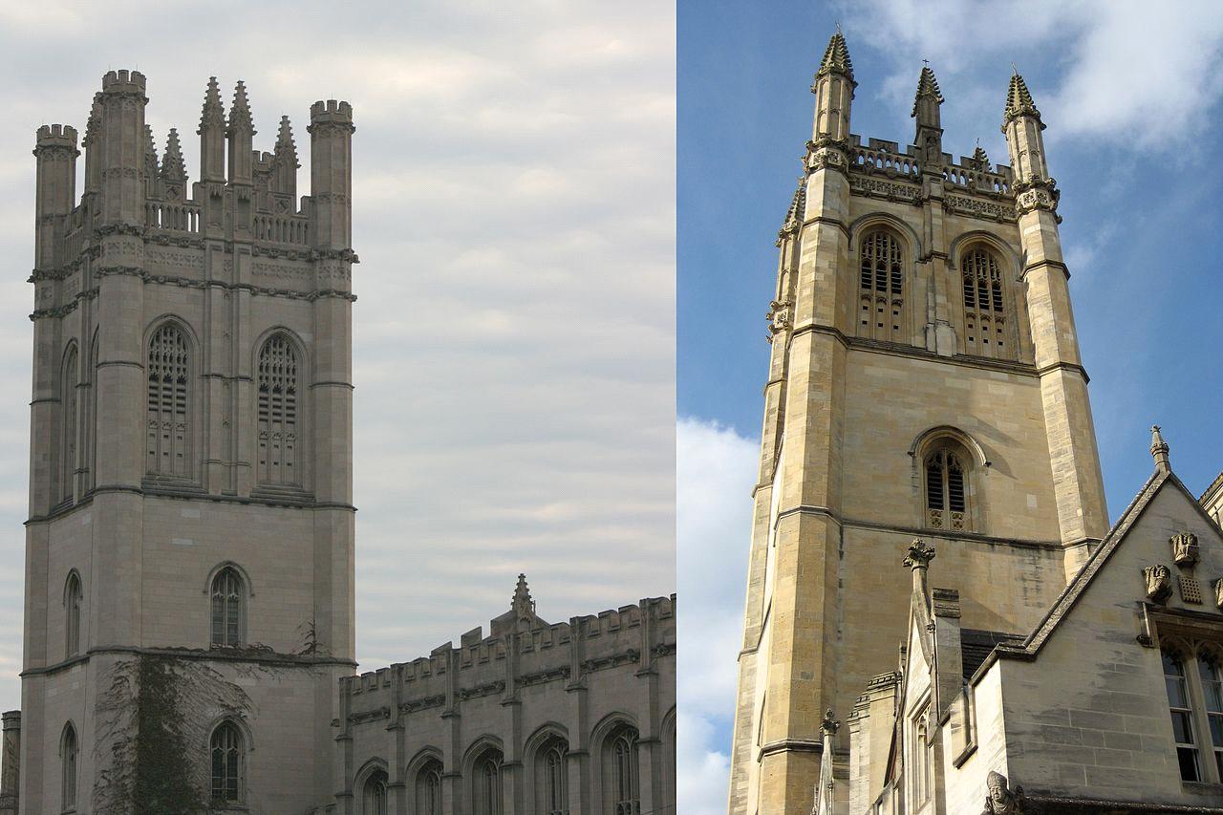University of Chicago

west palace of westminister

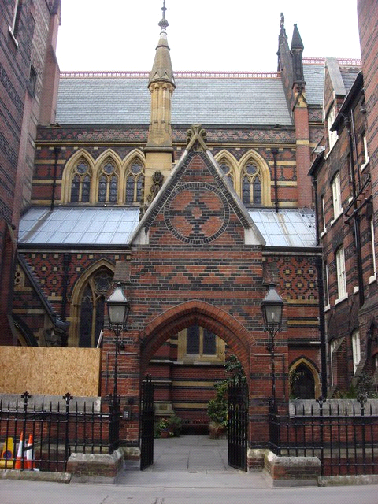All Saint Church In England

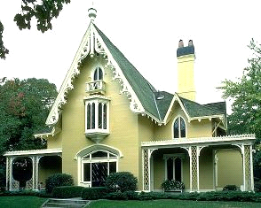

Residence

**GOTHIC FURNITURE:**

Most Gothic furniture has Gothic architectural details applied to contemporary furniture forms.  
1. Tracery and pointed arches distinguish Gothic Revival furniture.  
2. Simplistic, rectangular outline, incised or shallow-relief carvings, painted or inlaid geometric or naturalistic decor.  
3. The furniture matches the architecture it is placed inside.  
4. Backs of chairs often resemble rose windows or have pinnacles.  
5. Common pieces include: chairs, beds, tables, and storage.

HYPERLINK "http://designergirlee.files.wordpress.com/2011/07/gothic-revival-side-chair.jpg"HYPERLINK "http://designergirlee.files.wordpress.com/2011/07/gothic-revival-side-chair.jpg"  
HYPERLINK "http://designergirlee.files.wordpress.com/2011/07/gothic-revival-side-chair-2.jpg"HYPERLINK "http://designergirlee.files.wordpress.com/2011/07/gothic-revival-side-chair-2.jpg"  
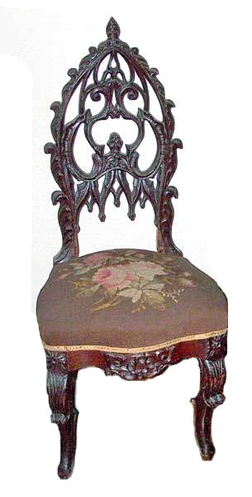HYPERLINK "http://designergirlee.files.wordpress.com/2011/07/gothic-revival-table.gif"HYPERLINK "http://designergirlee.files.wordpress.com/2011/07/gothic-revival-table.gif"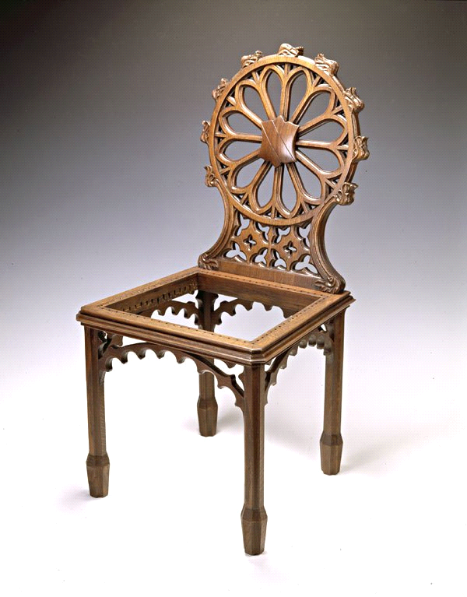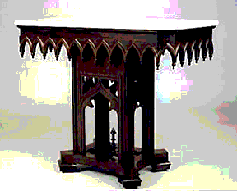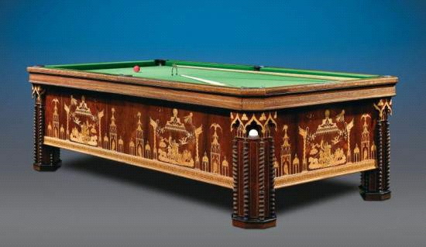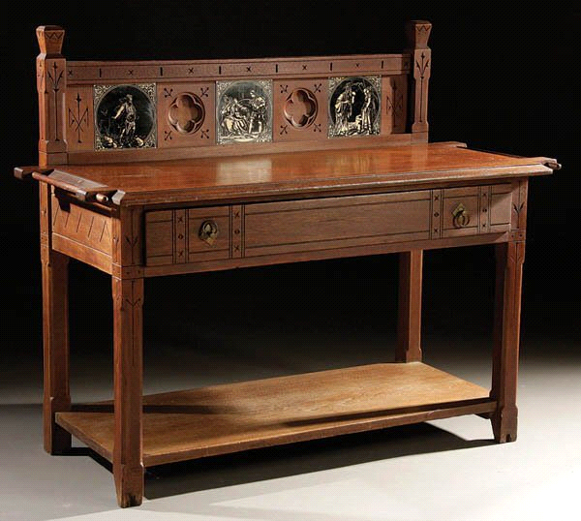

Motifs include pointed arches, pinnacles, battlements, crockets, stained glass, tracery, rose windows, cluster columns, oak leaves.

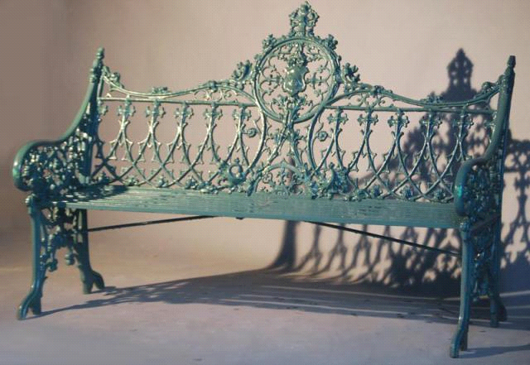

Finally, the Decorative Arts – Gothic Revival pervades all decorative arts from ceramics to silver to clocks to fireplace furniture.

HYPERLINK "http://designergirlee.files.wordpress.com/2011/07/old-state-capitol-in-baton-rouge-interior-staircase.jpg"HYPERLINK "http://designergirlee.files.wordpress.com/2011/07/old-state-capitol-in-baton-rouge-interior-staircase.jpg"  
HYPERLINK "http://designergirlee.files.wordpress.com/2011/07/gothic-revival-ceramic-tea-picture.jpg"HYPERLINK "http://designergirlee.files.wordpress.com/2011/07/gothic-revival-ceramic-tea-picture.jpg"  
HYPERLINK "http://designergirlee.files.wordpress.com/2011/07/gothic-revival-candlestick-holders.jpg"HYPERLINK "http://designergirlee.files.wordpress.com/2011/07/gothic-revival-candlestick-holders.jpg"  
HYPERLINK "http://designergirlee.files.wordpress.com/2011/07/gothic-revival-ceramic-pottery.jpg"HYPERLINK "http://designergirlee.files.wordpress.com/2011/07/gothic-revival-ceramic-pottery.jpg"